Agricultural Weather Station

Project report submitted in partial fulfillment of the requirement for the degree of

BACHELOR OF TECHNOLOGY

IN

ELECTRONICS AND COMMUNICATION ENGINEERING

By

ADITYA MISHRA 181023

UNDER THE GUIDANCE OF

Mr. Pankaj Kumar



JAYPEE UNIVERSITY OF INFORMATION TECHNOLOGY, WAKNAGHAT
May, 2021

TABLE OF CONTENTS

CAPTION PAGE NO.

DECLARATION i
ACKNOWLEDGEMENT ii
LIST OF ACRONYMS AND ABBREVIATIONS iii
LIST OF SYMBOLS iv
LIST OF FIGURES v
LIST OF TABLES vi
ABSTRACT vii

CHAPTER-1: INTRODUCTION 8-9
1.1 Introduction 8

1.2 Agriculture 8
1.2.1 Statistic 8
1.2.2 Water 9

CHAPTER-2: Internet of Things 10
2.1 Introduction 10
2.2 IoT in Agriculture 10

CHAPTER-3: Weather station 11
3.1 Weather Station 11

3.2 Weather and Agriculture 11
3.2.1 Uses of Weather forecast 11
3.2.2 Component of AWS 12
3.2.3 Types of AWS 13
CHAPTER-4: smart agriculture 14
4.1 Smart Agriculture 14
4.1.1 Smart Agriculture 14
CHAPTER-5: AgriWeather Station 15
5.1 Project Overview 15

5.2 Working of AWS 18

5.3 Schematic and flow chart 19

5.4 Circuit Diagram 20

5.5 Component and uses 21
5.5.1 Arduino UNO Microcontroller 21
5.5.2 ESPN8266 Wifi Module 22
5.5.3 BMP280 Pressure Sensor 23
5.5.4 Soil Moisture Sensor 24
5.5.5 DS18B20 Soil Temperature Sensor 25
5.5.6 DHT11 Temperature and Humidity 26

5.6 Results 27

CHAPTER-6:Conclusion 29

CHAPTER-7: Future Work 30

REFERENCES
APPENDIX
PUBLICATIONS
PLAGIARISM REPORT

DECLARATION

We hereby declare that the work reported in the B.Tech Project Report entitled “Agricultural Weather Station” submitted at Jaypee University of Information Technology, Waknaghat, India is an authentic record of our work carried out under the supervision of Mr. Pankaj Kumar. We have not submitted this work elsewhere for any other degree or diploma.

Aditya Mishra
181023

This is to certify that the above statement made by the candidates is correct to the best of my knowledge.

Signature of the Supervisor
Name of the Supervisor
Date:

Head of the Department/Project Coordinator

ACKNOWLEDGEMENT

I would like to take the opportunity to thank and express my deep sense of gratitude to my mentor and project guide Mr. Pankaj Kumar for his immense support and valuable guidance. My friends and classmates without these people it would not have been possible to reach at this stage of our minor project.

Date: 20/04/2021

Aditya Mishra
181023

LIST OF ACRONYMS AND ABBREVIATIONS

- IoT - Internet of Things
- AWS - Agricultural Weather System

LIST OF SYMBOLS

LIST OF FIGURES

Figure 2.1: IoT in Agriculture
Figure 5.1 : AgriWeather System
Figure 5.2: AWS installed in a box
Figure 5.3: AWS reading plant data
Figure 5.4 Arduino UNO
Figure 5.5 ESPN8266 WiFi
Figure 5.6 BMP8266 Pressure Sensor
Figure 5.7 Soil Moisture Sensor
Figure 5.8 DS18B20 Soil Temperature Sensor
Figure 5.9 DHT11 Temperature and Humidity
Figure 5.10 Soil Moisture
Figure 5.11 Soil Temperature
Figure 5.12 Area Temperature
Figure 5.13 Humidity
Figure 5.14 Pressure Sensor

LIST OF TABLES

Table 3.1: AWS types and utility[8]
Table 3.2: Weather Requirement for farming operations[9]

ABSTRACT

With the outstanding development of inhabitants, the UN Food and Agriculture Association says that we are required to deliver 70% more food in 2050, rural grounds are decreasing, and consumption of limited resources, the need to improve field yieldáhas gottenábasic. Crampedáaccessibility of commonáassets, for example, áwater andáfruitful land with the previous yieldápatterns in a fewástaple harvests, have additionally troubledáthe issue. Another blocking worryáover the cultivation work is the moving construction of agrarian labor force. Also, rural workáin the vast majority of the stateáhas declined. Because of the declining rural labor force, selection of internet connectivity and farm data monitoring is required, to decrease the requirement for difficult manual work labour and increase the yield with minimum impact on economical health of producer and physical health of consumer.
CHAPTER 1

INTRODUCTION

1.1 Introductioná

"Ifáconservationáof natural resources goes wrong, nothing else will goáright" (M. S. Swaminathan). The demand and supply of food were never the same throughout history. With this exponential population growth, we will be left with less land to produce with more people to feed.

The world populace will touch 9.8 billion in 2050[1] nearly, a 25% increase. This increase will happen mainly in developing countries. With this rapid increase, people will tend to move towards urban areas. According to a UN report, 70% of the world population will be urban till 2050[2]. Urbanization will change the land usages of that area, farms and cultivable lands would get converted into buildings and parks that would result in less cultivable lands. With Urbanization, people will be likely to spend more on quality and nutritious food products. This increase in demand for quality, quantity, and nutritious food items will cause a strain on the already stressed food sector.

1.2 Agriculture
1.2.1 Statistic
Farming is the science, workmanship and practice of developing plants and domesticated animals. Agribusiness area in India utilized about 60% (2017) of the labor force and contributed 16% of Gross domestic product in 2016-17[2].Indiaáis the 2nd biggest produceráof fruits
and vegetables on the earth. Absolute region under green yields isá25.43 million haá(2017-18) and
productionáis 311.71 millionátons (2017-18). Fruitsáand vegetablesá contributeáabout 90%áof the complete greenácreation in the country[2].Rice, wheat, cotton, oil seeds, jute, tea, sugarcane, milk and potatoes are the major horticultural wares delivered. All the moreásignificantly, more thaná60% of the nation's populace, involving a few million small farmers, relies upon agribusiness as a chief pay sourceáand land keeps onábeing the principle resourceáfor job security.

1.2.2 Agriculture and Water
The most valuable resource we got to sustain life on planet Earth is water. Aboutá97%áofáEarth's
wateráis salt-wateráheld by seasáandáoceans and justátheáleftover 3%áis freshwater—moreáthan two-thirdáis frozenáin the typesáof icy massesáand polar iceácovers[3][4]. Just 0.5%áof the thawedánew water isáover the ground,áas the restálies underground [5].Ináshort, we relyáon this 0.5%áto fulfill alláour requirements andáto maintain theáecosystem.

The horticulture industryáutilizes roughly 70%áof this openáwater[6]. India hasá18% of theáworld's
population, havingá4% of theáworld’s freshwater, 80%áis used ináagriculture[7]. According toáUN
convention toácombat desertification (UNCCD)áestimates in 2013áshow that thereáare 168countriesáaffected by desertificationáand by 2030,áalmost half ofáthe world populationáwill be livingáin areas witháwater shortage. Asáper UN conventionáto combat desertificationá(UNCCD) estimates iná2013 show thatáthere are 168ánations influenced byádesertification and byá2030, practically 50%áof the theátotal populace willábe living inázones with a lack of water.

CHAPTER 2

INTERNET OF THINGS

2.1 IoT
Internet of Things is defined as a mess of different physical objects that connect and communicate with each other while collecting, sending, and analyzing data. It’s a mess of sensors and actuators that help in monitoring and performing the functionality according to the data gained.

2.1.1 Applications
Smart Home
Elder Care
Medical and healthcare
Transportation

2.2 IoT in Agriculture

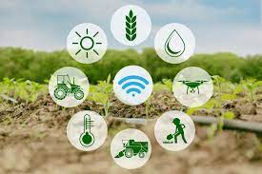
Figure 2.1: IoT in Agriculture

IoT connects various devices together which are equipped with sensing, processing, and communicating with network capability. In agriculture, there are many aspects to consider from soil health to water, pests, and weeds. Balancing all these variables gives a proper output. But the proper output is not the case required in this modern time, fields are required to maximize their yield without compromising the health of the plant and that of the consumer. This requires a systematic and sustainable approach towards precision farming.

CHAPTER 3
WEATHER STATION

3.1 Weather Station

A facility on land or in sea responsible to collect and measure the atmospheric condition in or around the area where system is installed.It helps us to take precaution against destructive natural disaster caused due to heavy rain, winds and other atmospheric activities.

3.2 Weather and Agriculture
Agriculture directly depends upon the Weather and Climate of that locality. Among the many parts involved in agriculture like water and soil health, the weather act as a moderator in between them. It brings rain, cools the temperature, but can cause drought and conditions that can cause severe damage to the crop.

3.2.1 Use of Weather forecast
Agronomic activities require the weather to sow and irrigate the plants or if conditions are not good, then delay its sowing process. A few parts of climate gauges for horticulture are very unmistakable from succinct climate figures. In concise meteorology, the beginning and withdrawal of the rain are identified with changes in wind dissemination designed in the upper climate and relative changes in the precipitable water droplet of air in the lower layers. Planning of fields for planting the harvest with a satisfactory amount of seed growth, soil dampness requires extensive downpours.

3.2.2 Components of AWS

  - CloudáCover
  - Rainfall
  - Maximumáand MinimumáTemperature
  - RelativeáHumidity
  - WindáSpeed
  - Heatwave
  - Lowáand High pressure
  - Solar Radiation
  - Bright hour of day light
  - Soil Dampness

3.2.3 Types of AWS
- Nowácast
- Very shortárangeáforecast
- Short rangeáforecast
- Medium rangeáforecast
- Longárange forecast

Table 3.1: AWS types and utility[8]
Types | Accuracy
Now cast | Very high
Very short range | Very high
Short range | High
Medium Range | Moderate
Long | Very low

Table 3.2: Weather Requirement for farming operations[9]

Farming | Weather Condition | Soil | Air Temperature
Land Preparation | Clear or Cloudy day | Moist | 15°C ---- 40°C
Seeding | Clear or Cloudy | Moist | 15°C ---- 33°C
Relocating seedlings | Clear or cloudy day | Wet | 15°C ---- 40°C
Cultivating | Clear to partly cloudy | Moist or dry | 15°C ---- 40°C
Irrigation | clear or cloudy day | moist or dry | Above 14°C
Spraying | Clear | moist or dry | 15°C ---- 33°C
Threshing | Clear to partly cloudy | dry | Above 14°C

Table 3.2 shows the optimum temperature and condition required for the growth of plants. This result is briefly discussed in Guide to AgriculturaláMeteorological Practices,2010,Chapterá5.

CHAPTER 4
SMART AGRICULTURE
4.1 Smart Agriculture
Agriculture is the practice of growing eatable items. Different aspects are involved in this process, from soil to seed, from field to feast. Managing these processes through sensors and actuators leads to micromanagement with reduced environmental effects. This way of Agriculture is Smart Agriculture.

4.1.1 Smart Agriculture and IoT
With the increase in demand for food, it is required to produce more with a sustainable approach, taking care of each natural resource. Upon taking the above facts and figures of the requirement to monitor plant health and environment, IoT plays a crucial role.áIoT-based Smart Agriculture: Towards Makingáthe field Talk[10] discusses the use of IoT in agriculture it emphasizes more intelligent, better, and more productive harvest developingátechniques needed to meetáthe developing food requestáof the expandingátotal populace evenáwith the consistentlyácontracting arable land.áThe advancement ofáa new techniqueáfor improving harvestáyield and takingácare of, oneácan promptly seeáat present: innovationáweaned, creative moreáyouthful individuals embracingácultivation as aácalling, horticulture asáaámethod for autonomyáfrom petroleum derivatives, following the harvest development, wellbeing and nourishment marking, organizations between producers, providers, retailers, and purchasers.All these angles and featured the job of different advances, particularly IoT, to make horticulture more brilliant and more effective to meet future assumptions. For this reason, remote sensors, UAVs, Cloud-registering, correspondence innovations are talked about altogether. Moreover,áaámore profound knowledge intoálate exploration endeavors haságiven. Furthermore, different IoT-basedádesigns and stages hadágiven concerning agribusiness applications.áA synopsis ofácurrent difficulties confrontingáthe business andáfuture assumptions isáleading to controláanalysts and designers.áIn light ofáthis, it veryáwell may beáinferred that everyálast trace ofáfarmland is indispensableáto augment cropácreation.
Notwithstanding, to manage each inch as needs be,áthe utilization of maintainableáIoT-based sensors and correspondenceáinnovations are most certainly not discretionary—it is fundamental

CHAPTER 5
AGRIWEATHER

5.1 PROJECT OVERVIEW
The increase in demand for food, food products, and climate changes causing an issue related to the production and health of crops. Planned agriculture is required to tackle these issues with effectiveness. The solution must be farmers friendly, cost-effective with minimum moving, and time taking functionality with an accurate and precise result.

Upon reviewing the problems that occurred in the farming procedure, overuse of fertilizers and water, a cost-effective and robust solution necessary to improve the yield with minimum impact on the environment.

AgriWeather stands for Agricultural Weather Station is the solution provided to tackle the issues of monitoring Weather Data of that particular field area. AgriWeather is a device that can record temperature of that area, temperature of Soil, Humidity of that area, Humidity of the Soil, daylight intensity, air pressure and sends this data to a remote server which acts as a display where user can see and analyse the data.

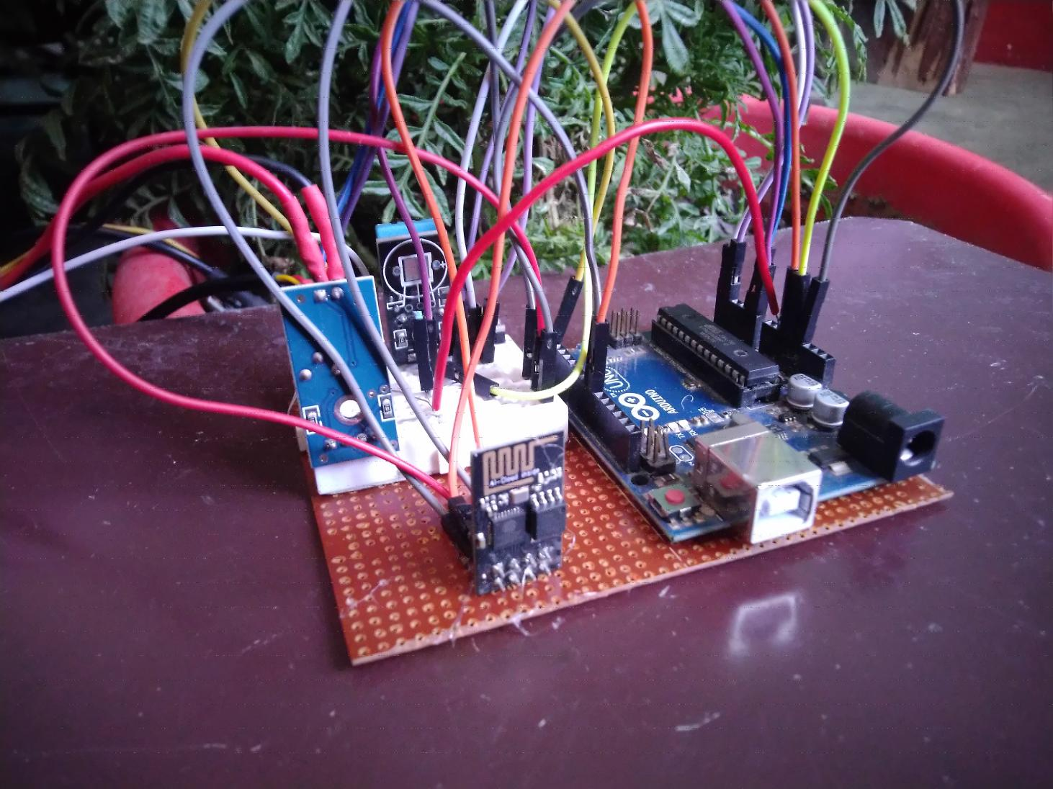
Figure 5.1 : AgriWeather System

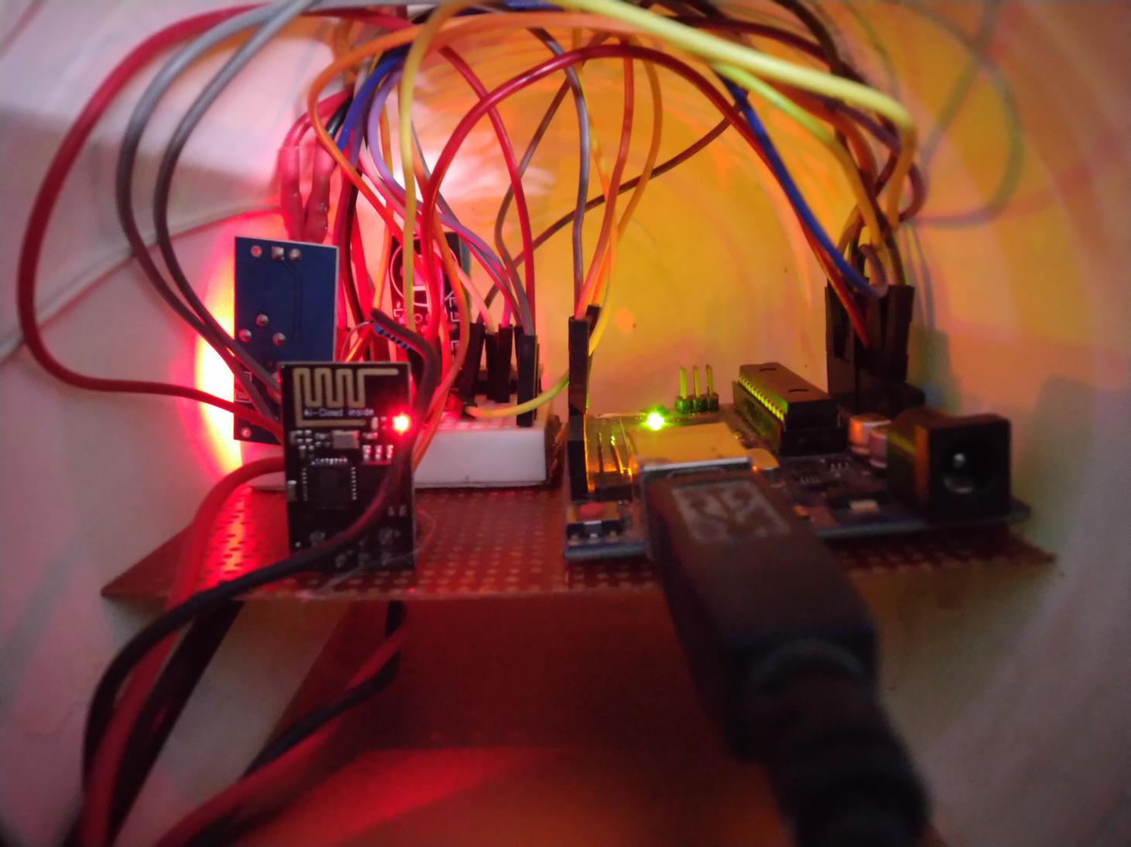
Figure 5.2: AWS installed in a box

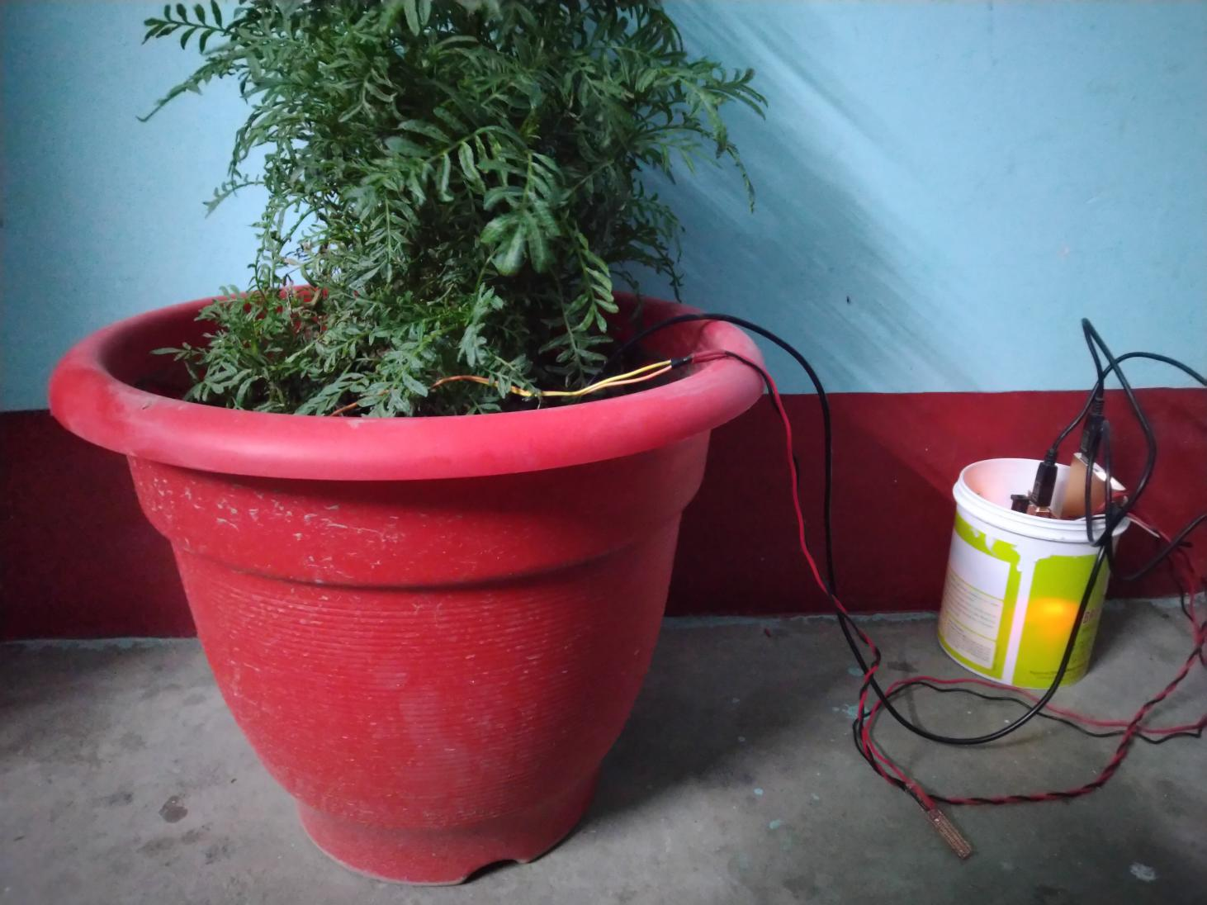
Figure 5.3: AWS reading plant data

5.2 Working of AWS

The data given in Table 3.2 give us the impression of measuring temperature and air pressure to get the best fit time for performing farming activities. This system can monitor Temperature with DHT11 Sensor, Air pressure BMP280 Sensor, Temperature of Soil DS18B20, and daylight with Infrared Sensor, Soil Moisture with Soil Moisture Sensor.

Device act as a read and write NowCast System showing the real time data to the user through ThinkSpeak Server.

5.3 Schematic and flow chart

SOIL MOISTURE SENSOR
RAIN GUAGE SENSOR
AIR PRESSURE SENSOR
TEMPERATURE SENSOR

Infrared Sensor
MICROCONTROLLER

CLOUD

WiFi

5.4 Circuit Diagram

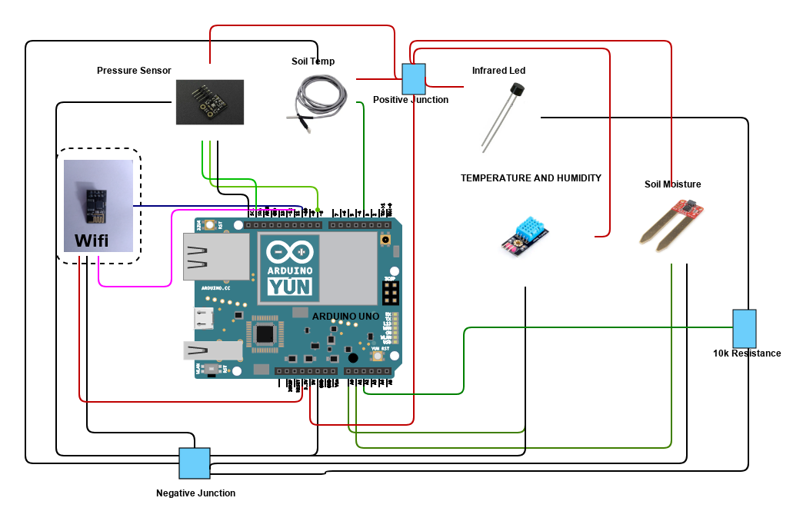

5.5 Component and Uses

- Arduino UNO Microcontroller
- ESPN8266 WiFi Module
- BMP280 Pressure Sensor
- Soil Moisture Sensor
- DS18B20 Soil Temperature Sensor
- DHT11 Temperature and Humidity

5.5.1 Arduino UNO Microcontroller

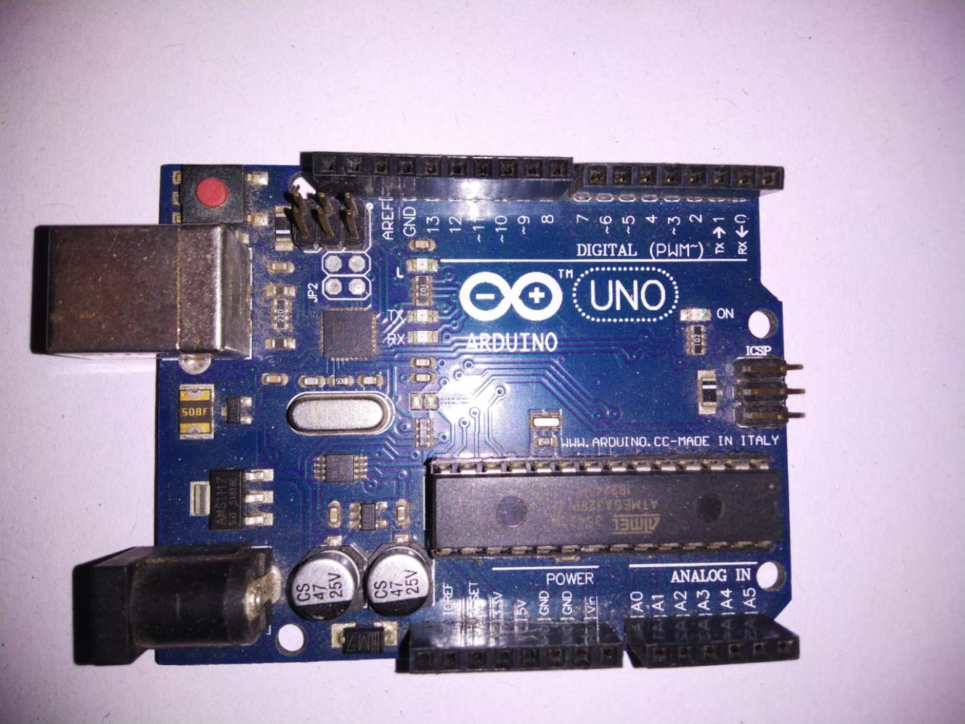
Figure 5.4 Arduino UNO

- Microcontroller: Microchip ATmega328P
- Operating Voltage: 5 Volts
- Input Voltage: 7 to 20 Volts
- Digital I/O Pins: 14 (of which 6 can provide PWM output)
- UART protocol: 1
- I2C protocol: 1
- SPPI: 1
- Analog Input Pins in Arduino: 6
- DC Current per I/O Pin: 20 mA
- DC Current for 3.3V Pin: 50 mA
- Flash Memory: 32 KB of which 0.5 KB used by bootloader
- SRAM: 2 KB
- EEPROM: 1 KB
- Clock Speed: 16 MHz
- Length: 68.6 mm
- Width: 53.4 mm
- Weight: 25 g
Farm lands are located far from cities and have few to no power supply units. So Arduino Uno is the best suited mircrocontroller for using in low power supply zone with maximum output.
5.5.2 ESPN8266 Wifi Module
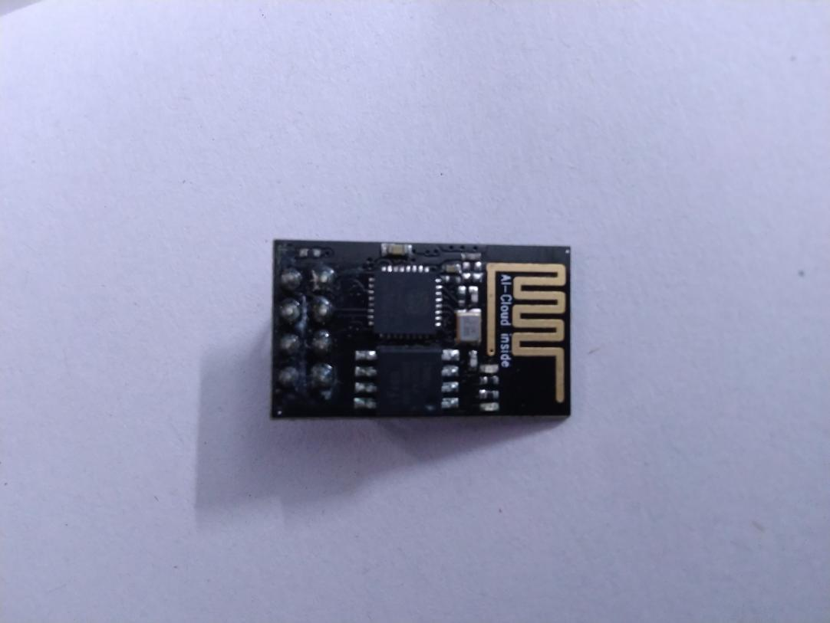
Figure 5.5 ESPN8266 WiFi

Features:
Low power supply 3.3v
Compact design
Flash memory 512kb
Support Station and Access Point mode
2.4 GHz Wifi
I2C Communication

While dealing with network infrastructure using wifi to send data, helped in saving on the costs and maintainability of this project.

In project Wifi pins are connected to pin 10 -Rx and pin 11 to Tx
Power supply pin with Ch_pd to 3.3v
And ground Pin to Ground

5.5.3 BMP280 Pressure Sensor

- It contains a capacitive plate connect with the atmosphere
- The deformation in diaphragm results in detection of Atmospheric pressure.
- Lower the pressure, lower the movement of diaphragm and vice-versa, which results the value of barometer.
- Lower barometer reading means decrease in air pressure it indicates higher chances of rain
- Increased in reading indicates clear or dry air sky.

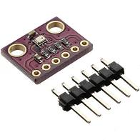
Figure 5.6 BMP8266 Pressure Sensor

5.5.4 Soil Moisture Sensor

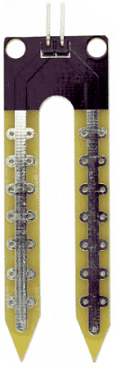
Figure 5.7 Soil Moisture Sensor

Soil dampness sensor has two leading plates. First plate is associated with the +5Volt supply through arrangement resistance of 10K ohm and second plate is associated straightforwardly to the ground.

It just goesáabout as aávoltage divider network, andáyield is takenástraightforwardly fromáthe maináterminal of theásensor pin.

Theáyield willáchange in theáscope of 0 – 5 Volt, ináextent with change in substanceáof waterá ináthe dirt.

Preferably,áwhen there isázero dampness in soil,áthe sensor goesáabout as openácircuit for example endlessáobstruction. For thisácondition, we getá5V at the yield.

5.5.5 DS18B20 Soil Temperature Sensor

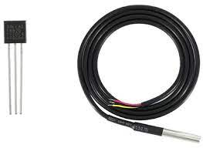
Figure 5.8 DS18B20 Soil Temperature Sensor

Programmable Temperature Sensor
One Wire Communication
Temperature Range : -55°C to +125°C
Output: 9 to 12 bit
Conversion duration: 750ms

The DS18B20 is a 1-wire programmable Temperature sensor.Used in condition where ordinary sensors are not that useful or cannot get through.The built of sensor is robust and water resistance.

Temperature Measurement - 55°C to +125° with error ±5°C.

It uses one wire for communication.

5.5.6 DHT11 Temperature and Humidity
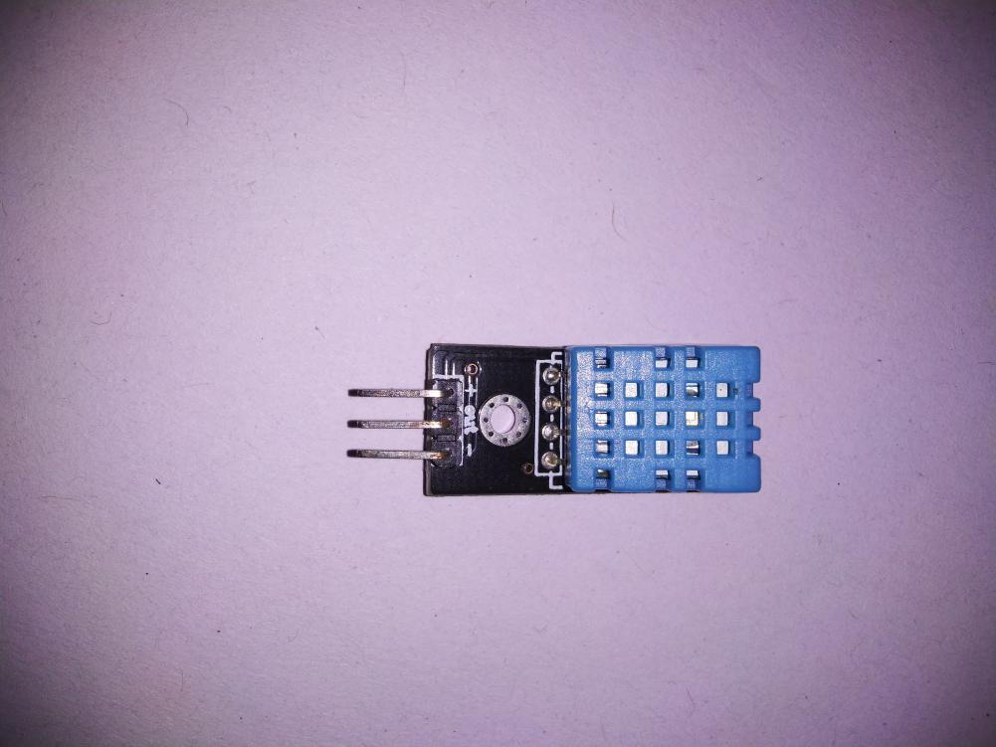
Figure 5.9 DHT11 Temperature and Humidity

Humidity is measured by the help of two electrode with moisture holding electrode in between them. With change in humidity the conductivity changes so the resistance changes. The change in resistance is measure and processed by IC and feed to microcontroller.
While temperature is measured by a NTC temperature sensor thermistor, it is a variable resistor which changes with change in temperature.

5.6 Result

The reading of Sensors is sent to ThinkSpeak Server with the help of TCP/IP connection.
ThinkSpeak Shows the result to the user in graphical format as shown.

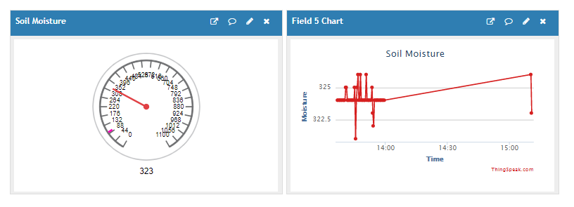
Figure 5.10 Soil Moisture

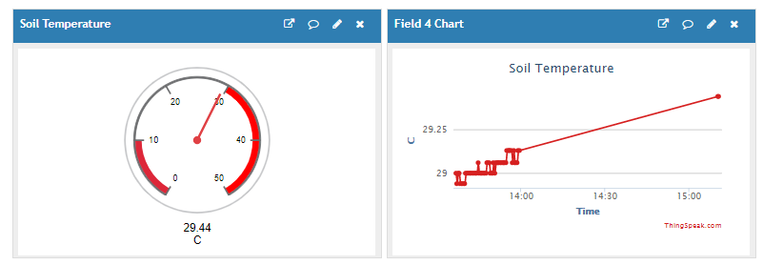
Figure 5.11 Soil Temperature

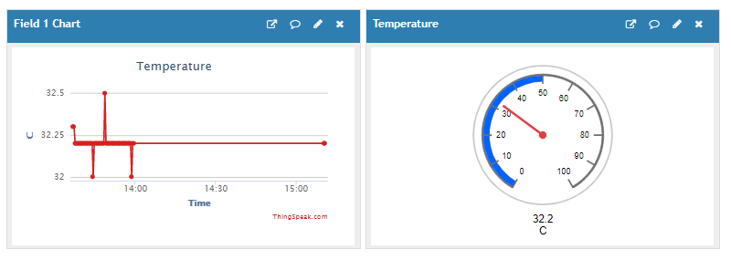
Figure 5.12 Area Temperature

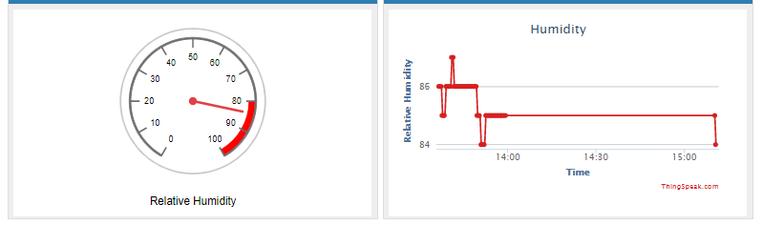
Figure 5.13 Humidity

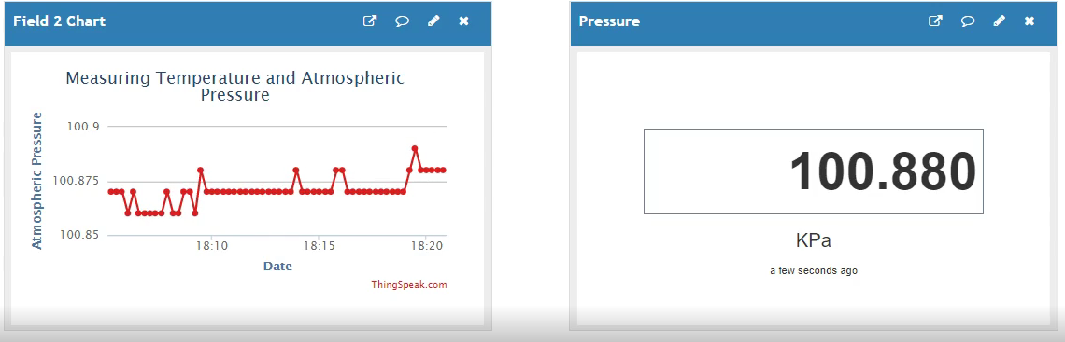
Figure 5.14 Pressure Sensor

CHAPTER 6
CONCLUSION

6.1 Conclusion

With the rapid growth of population and demands, these types of applications are the need of the time to help farmers, especially in India to increase their productivity without much of the labor work. As the industry is growing with rapid race, the involvement of youth is the key factor to drive the growth of the agricultural industry. Based on the problems and research done in this field this type of products is the dire need of today's world so that we can tackle the issues of growth and demand while taking the necessary step to lower the overuse of resources and increasing the production with a sustainable and suitable approach.

CHAPTER 7
FUTURE WORK

7.1 Future Work

This project is in development phase the first step was to implement the sensors and hardware to work as Weather Station. These data shown here are raw data of the environment.The next phase of this project will be to gain data of a particular crop. Make this device more robust. And to implement satellite data of that area along with the on site data and compare and predict the outcomes as according to the past and present data of that area with the help of Machine Leaning Algorithms.

Using a third party server is not that efficient as it does not provide the ability to process the data as users need so we will try to implement a server based project that stores, process and show results to the user without involvement of any third party application.

REFERENCES

[1] World Population Projected to Reach 9.8 Billion in 2050, and 11.2 Billion in 2100.[Online]. Available: https://www.un. org/development/desa/en/news/population/world-population-prospects2017.html
- Directorate of Economics & Statistics, Department of Agriculture Government of India.(2021, January). “January,2021”.“Agricultural Situation in India”[Online]. pp.11. Available: https://eands.dacnet.nic.in/PDF/January2021.pdf
- Ice, Snow, and Glaciers and the Water Cycle.[Online]. Available:https://water.usgs.gov/edu/watercycleice.html
- What Percent of Earth is Water? . [Online]. Available: https://phys.org/news/2014-12-percent-earth.html
- Water Facts Worldwide Water Supply. [Online]. Available: https://www.usbr.gov/mp/arwec/water-facts-ww-water-sup.html
- Water for Sustainable Food and Agriculture by FAO. [Online]. Available: https://www.fao.org/3/a-i7959e.pdf
- Dr.Vibha Dhawan,”Water and Agriculture in India”.”Background paper for the South Asia expert panel during the Global Forum for Food and Agriculture (GFFA) 2017 ”.Available: https://www.oav.de/fileadmin/user_upload/5_Publikationen/5_Studien/170118_Study_Water_Agriculture_India.pdf
- H.P. Das. Guide to Agricultural Meteorological Practices,2010,Chapter 5.
- H.P. Das. Guide to Agricultural Meteorological Practices,2010,Chapter 5,pp. 5-8.
- M. Ayaz, M.A Uddin,Z.Sharif, A. Mansour, El-hadi M. Aggoune,Internet-of-Things (IoT)- Based Smart Agriculture: Toward Making the Fields Talk, IEEE,Available:https://ieeexplore.ieee.org/document/8784034
- Tabassum, S. and Hossain, A. (2018) Design and Development of Weather Monitoring and Controlling System for a Smart Agro (Farm). Intelligent Control and Automation, 9, 65-73. https://doi.org/10.4236/ica.2018.93005

APPENDIX A

A.1 Software Code

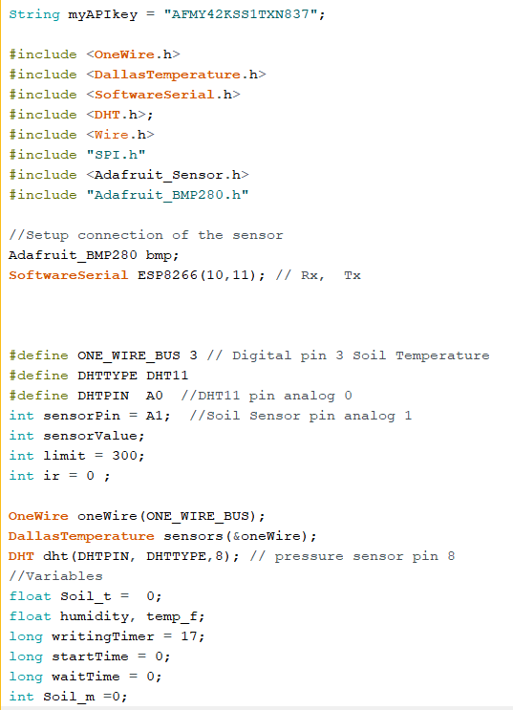

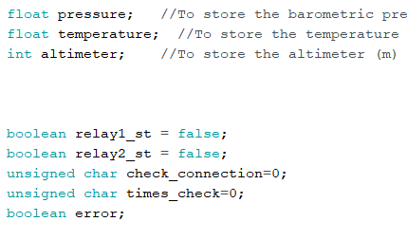

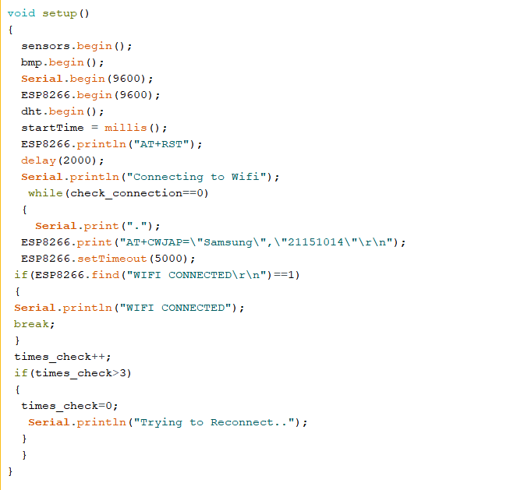

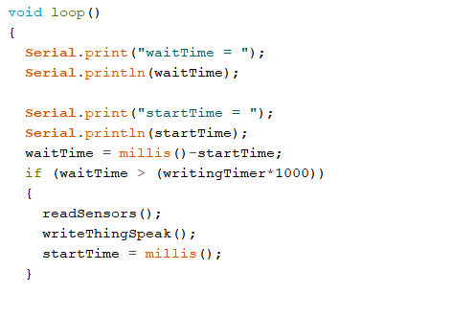
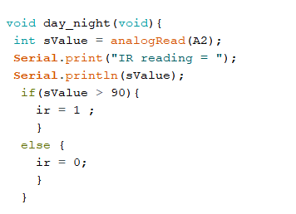
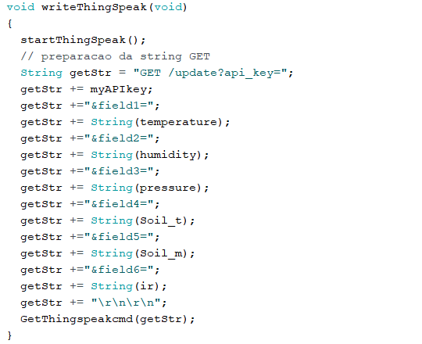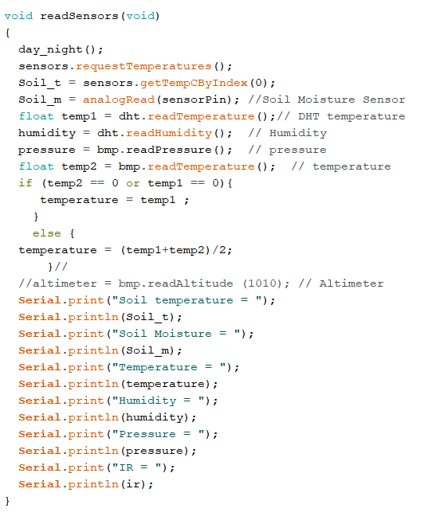
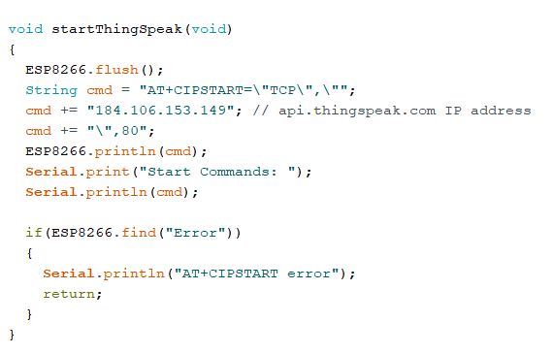
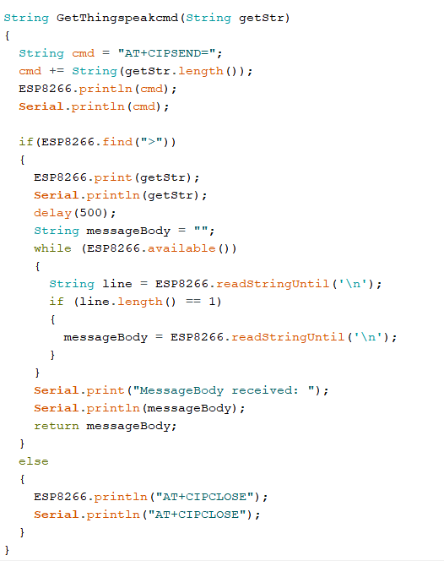
PLAGIARISM REPORT

